**ONLINE CERTIFICATION COURSE**

**NAME : Shrinivasa**

**USN : 4AL17CS092**

**COURSE NAME : Machine Learning with Python**

**LINK :** [**https://cognitiveclass.ai/courses**](https://cognitiveclass.ai/courses)

**Cognitive Class: ML0101ENv3**

**Org By : IBM**

**Start date : 18-05-2020**

**Duration : 12 hr**

**Status: Completed**

**Progress on 23-05-2020**

* **Topic Completed Today**

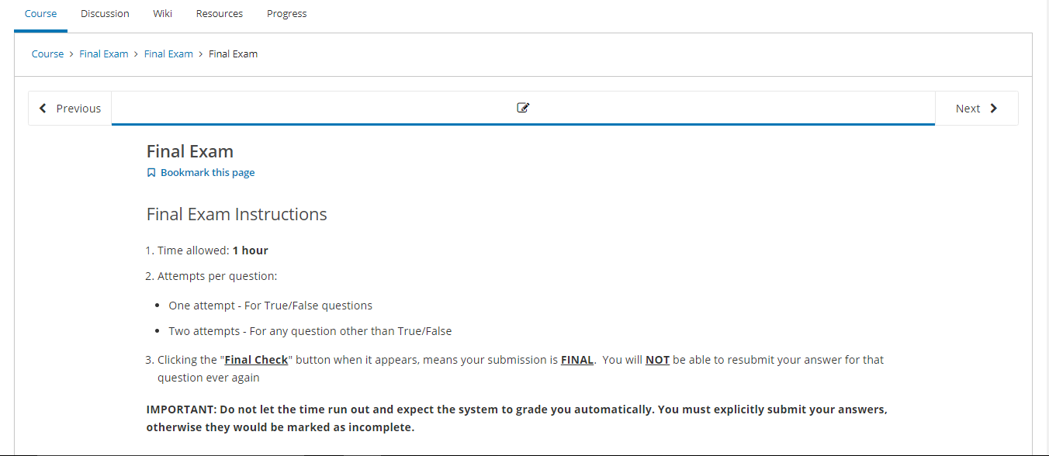

* **Progress Report**

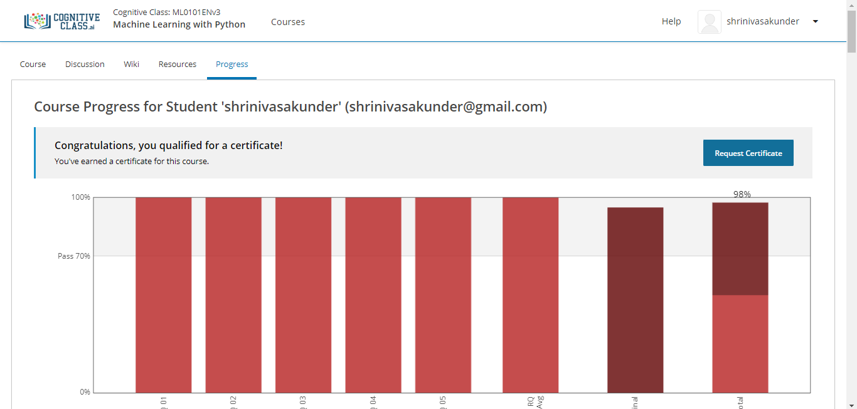

* **Certificate**

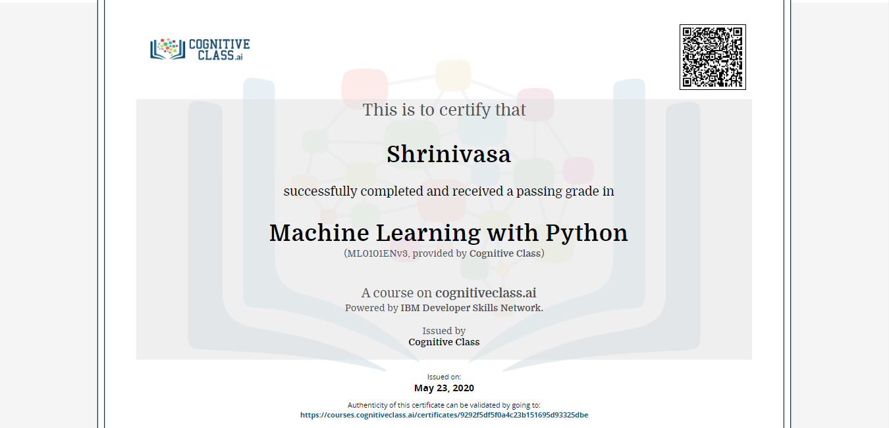

* **Badge**

